SAFETY AND PREDISPOSITION FOR INFECTIONS AFTER DENTAL PROCEDURES IN MECHANICAL ASSIST DEVICES (LVADs) RECIPIENTS
K.C. McCants, J.B. McCants, P.S. Combs, P. Raheja, E. Birks, M.S. Slaughter
University of Louisville & Jewish Hospital, Louisville, KY, USA

Objective: To assess the safety of dental procedures in patients with LVADs, in regards to infections and bleeding complication given their anticoagulation/ antiplatelet medication profile and acquired VWF deficiency.
Background: Currently more than 7,000 patients with heart failure are supported with LVADs. Therefore some patients with LVADs undergo these procedures which require review of their anticoagulation medication profile and antibiotic prophylaxis. Many centers adopt the AHA guidelines for the prophylaxis of bacterial endocarditis. Though these guidelines are comprehensive, they do not specifically address prophylactic recommendations for patients with LVADs. We would assume that these guidelines for prosthetic heart valves hold true for mechanical assist devices, however there is no current evidence.
Method: A protocol based pilot study of 13 LVAD patients using the AHA guidelines, who underwent dental procedures. We followed their respective clinical course for administration of preprocedural antibiotics, episodes of infective endocarditis, bacteremia, dental abscess, bleeding episodes, till six months after the procedure.
Results:
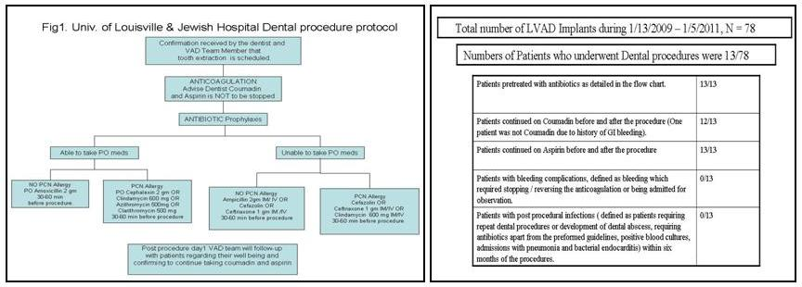

Conclusions: There was no increased risk of infections (dental abscess, pneumonia, infective endocarditis, and bacteremia) and no bleeding complications when the designed protocol was followed.

